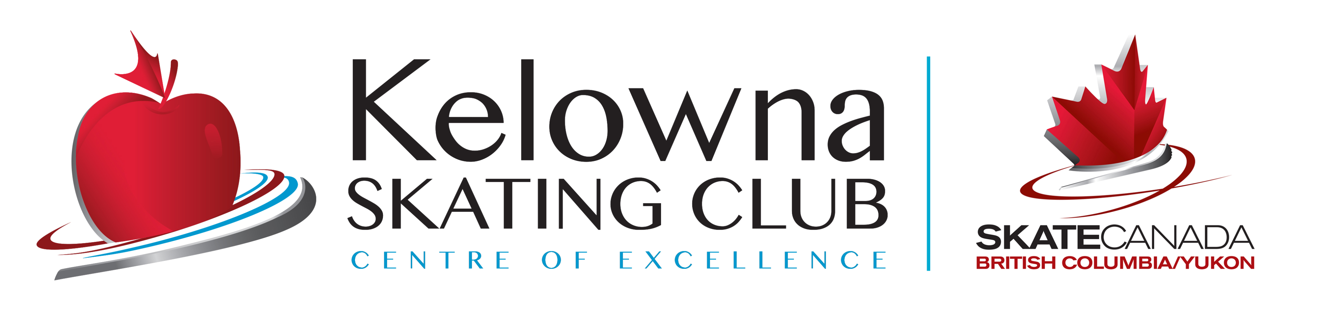
KELOWNA SKATING CLUB
Summer 2021
SKATING CLASSES
SCHEDULE
(Schedule is subject to adjustment dependent upon enrolment)
- CLASS | DAY | TIME | DATES | ARENA
- Junior Academy  - (10 classes) | - Mon-Fri | - 2:00-2:45pm | July 19th – July 30^{th,}2021 | CNC
- 11 & Under
CanSkate/  - CanSkate Youth | - Mon-Fri  - Mon-Fri | - 2:00-2:45pm  - 3:00-3:45pm | July 19th – July 30th, 2021 | CNC
- 5* & up
- (10 classes)

PLEASE NOTE:
- CanSkate Classes– CSA APPROVED HOCKEY HELMETS are MANDATORY – Your child will not be able to step on the ice without one!!!
- The Schedule is subject to change with notice due to COVID-19 restrictions. Any session may be cancelled due to insufficient registration.
- All ice, instruction are included in registration. A $45.00 Skate Canada insurance/membership fee will be charged once per skating year, September 1st – August 31st.
- No refunds. Refunds may be in the form of ‘credits’ and may be subject to a $25 Admin fee.
- A $40 charge will be applied to NSF cheques.

Email: recdirector.ksc@gmail.com
Website: www.kelownaskatingclub.com

