KELOWNA SKATING CLUB

SUMMER 2021 SKATING CLASSES
July 2021

WELCOME to the Kelowna Skating Club's 2021 Summer Recreational skating programs. We are sure you will find a class to suit your skating needs. All the skating classes are taught by ‘Skate Canada’ Certified Professional Coaches. The CanSkate sessions are fortunate to also have extra help from some of our test and competitive skaters who are certified ‘Skate Canada’ Program Assistants.
CANSKATE - Learn-To-Skate  This Learn-To-Skate Program is designed specifically for school age children 5 years & older. The fundamentals of skating emphasized include Balance, Posture, Forward and Backward skating, Stopping, Turning, Spinning, Jumping and the Four Basic Edges. Participants earn badges while learning basic skating skills. The CanSkate Learn-To-Skate classes are for skaters working on Stage 2 through Stage 6 of the CanSkate Badge Program.  DAY TIME ARENA FEES  Monday-Friday 3:00-3:45 pm CNC (10 classes) $165  *Canskate commences July 19th, 2021  * Skaters MUST be strong, independent skaters with previous Learn to Skate experience. Due to Covid-19 guidelines; Tot B/Stage 1 is required.  PLEASE NOTE – Fee Information:  Registration Fee includes ice and instruction. A $45.00 Skate Canada insurance/membership fee is included and will only be charged once per skating year, September 1st – August 31st.  NO REFUNDS except for medical reasons. Refunds will be in the form of ‘credits’ and may be subject to a $25 Admin fe  *Schedule subject to change due to COVID-19 guidelines & restrictions  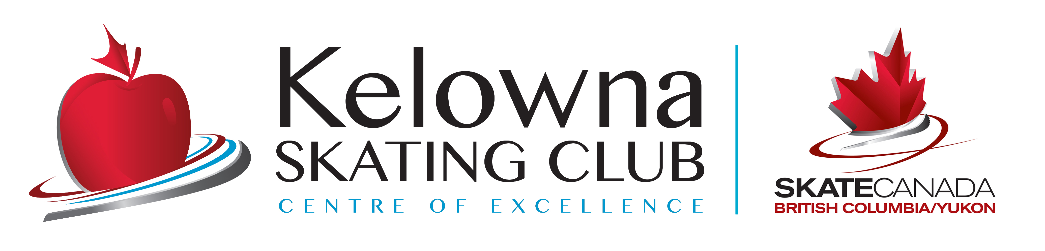 | JR ACADEMY – 11yrs & under  This Level of skating is for skaters 11 yrs & under that have PASSED the Stage 4 Badge of CanSkate. Participants will receive advanced coaching in small groups, continuing to progress through the CanSkate Badges with a focus on the fundamentals of Figure Skating. Graduates of this program will be prepared to enter into the KSC Test/Competitive programs.  DAY TIME ARENA FEES  Mon-Friday 2:00-2:45 pm CNC (10 classes) $135.00  *Jr. Academy commences July 19th, 2021  **For start and end dates please check the schedule online at www.kelownaskatingclub.com by clicking on the “Register Online” link and selecting the desired program.  For further information, or email:  Email: recdirector.ksc@gmail.com  REGISTER ONLINE  www.kelownaskatingclub.com

