KELOWNA SKATING CLUB
JUNE 2022
SKATING CLASSES
June 6th – June 30th, 20122

WELCOME to the Kelowna Skating Club's June Recreational skating programs. We are sure you will find a class to suit your skating needs. All the skating classes are taught by ‘Skate Canada’ Certified Professional Coaches. The CanSkate sessions are also fortunate to have extra help from some of our test and competitive skaters who are certified ‘Skate Canada’ Program Assistants.

CANSKATE – ‘TOTS’ (Learn-To-Skate)  The focus of this Program is to teach 4 & 5 year olds how to skate within a relaxed & fun atmosphere. The child must be able to work independently from parents and be comfortable in a group setting.  DAY: TIME: ARENA: FEES:  Mon & Thurs 3:30-4:00 pm CNC $108  (8 classes)  Tot programs commence week of June 6th, 2022  For further information email: recdirector.ksc@gmail.com  - No refunds except for medical reasons. Refunds will be in the form of ‘credits’ and may be subject to a $25 Admin fee.  KELOWNA SKATING CLUB  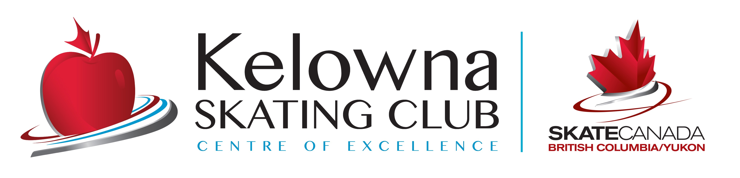 | JR ACADEMY – 11yrs & under  This Level of skating is for skaters 11 yrs & under that have PASSED the Stage 4 Badge of CanSkate. Participants will receive advanced coaching in small groups, continuing to progress through the CanSkate Badges with a focus on the fundamentals of Figure Skating. Graduates of this program will be prepared to enter into the KSC Test/Competitive programs.  DAY: TIME: ARENA: FEES:  Mon & Thurs 3:15-4:00 pm CNC $120.00  (8 classes)  Junior program commencing week of June 6th, 2022  Email: recdirector.ksc@gmail.com
**CSA approved HOCKEY helmets are MANDATORY forTots classes, your child will NOT be permitted on the ice without one.***

As of April 25th, 2022

