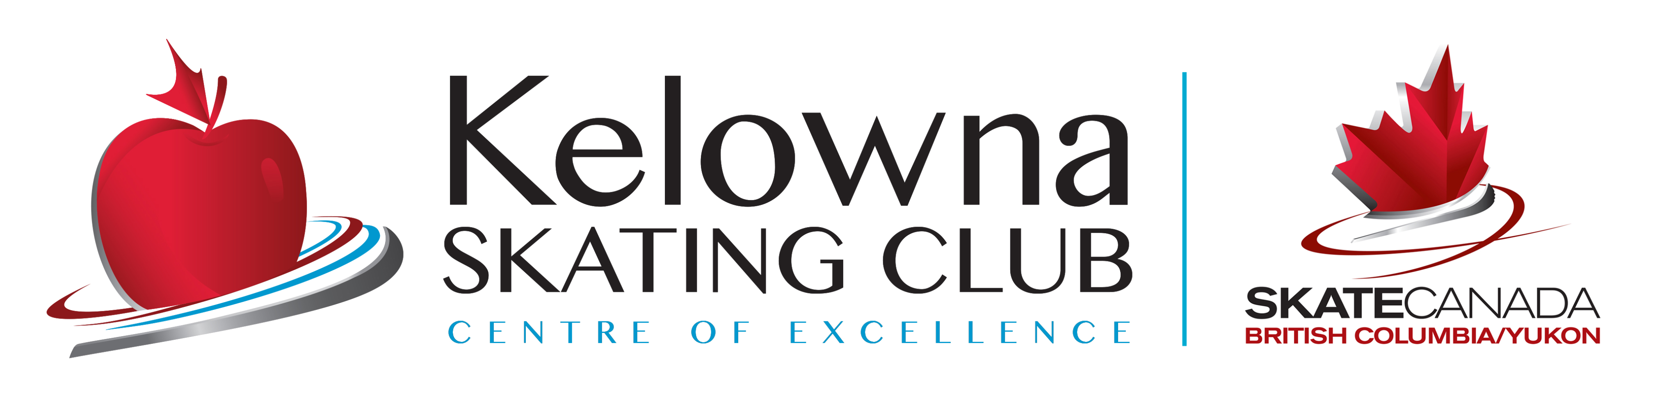

KELOWNA SKATING CLUB
June 2022
SKATING CLASSES
SCHEDULE
- CLASS | DAY | TIME | DATES | ARENA
- Tots 4&5 yrs  - (8 classes) | - Mon/Thurs | - 3:30-4:00pm | June 6th – June 30th 2022 | - Capital News Centre
- Junior Academy  - (8 classes) | - Mon/Thurs | - 3:15-4:00pm | June 6th – June 30th 2022 | Capital News Center
(Schedule is subject to adjustment dependent upon enrolment)

- PLEASE NOTE:
- Tots & CanSkate Classes– CSA APPROVED HOCKEY HELMETS are MANDATORY – Your child will not be able to step on the ice without one!!
- The Schedule is subject to change with notice. Any session may be cancelled due to insufficient registration.
- All ice and instruction fees are included in registration. An additional $45.00 Skate Canada Membership/Insurance fee will be charged once per skating season Sept 1st – August 31st.
- No refunds except for medical reasons. Refunds will be in the form of ‘credits’ and may be subject to a $25 Admin fee.
- A $40 charge will be applied to NSF cheques.

Kelowna Skating Club
Email: recdirector.ksc@gmail.com
Website: www.kelownaskatingclub.com
As of April 19, 2022

